Frequently Asked Questions (FAQ)

- Who are SANVY Solutions?
We are five free-thinking individuals with different tastes, aesthetics, opinions and backgrounds. We have all come together to create a company whose foundation is built on mutual trust, passion, and drive for what we do and an enthusiasm for the solution we create. We work hard, laugh often, and collaborate with amazing people. We invest all of our energy in making your software easily usable. We know that we do the best job for our clients each and every time when we provide a solution.
- What is PROMA?
PROMA stands for (Proactive Maintenance). Proactive maintenance is a maintenance strategy for stabilizing the availability and reliability of equipment. It involves corrective actions aimed at failure root causes, not active failure symptoms, faults, or machine wear conditions.
- What platform does PROMA work on?
PROMA works on the JAVA platform and the software being used is NetBeans IDE (www.netbeans.org).

- What is NetBeans?
NetBeans is an open-source project dedicated to providing rock solid software development products (theNetBeans IDE and the NetBeans Platform) that address the needs of developers, users and the businesses that rely on NetBeans as a basis for their products. The NetBeans IDE provides support for several languages (PHP, JavaFX, C/C++, JavaScript, etc.) and frameworks.
The IDE's GUI Builder makes it possible to build professional-looking GUIs without an intimate understanding of layout managers. You can lay out your forms by simply placing components where you want them.
The IDE's GUI Builder solves the core problem of Java GUI creation by streamlining the workflow of creating graphical interfaces, freeing developers from the complexities of Swing layout managers. It does this by extending the current NetBeans IDE GUI Builder to support a straightforward "Free Design" paradigm with simple layout rules that are easy to understand and use. As you lay out your form, the GUI Builder provides visual guidelines suggesting optimal spacing and alignment of components. In the background, the GUI Builder translates your design decisions into a functional UI that is implemented using the new GroupLayout layout manager and other Swing constructs. Because it uses a dynamic layout model, GUI's built with the GUI Builder behave as you would expect at runtime, adjusting to accommodate any changes you make without altering the defined relationships between components.

- Who is Admin and what data can Admin access?
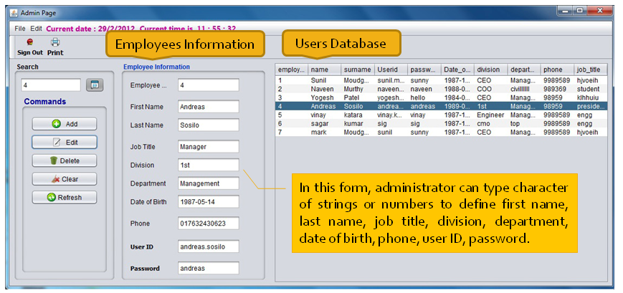
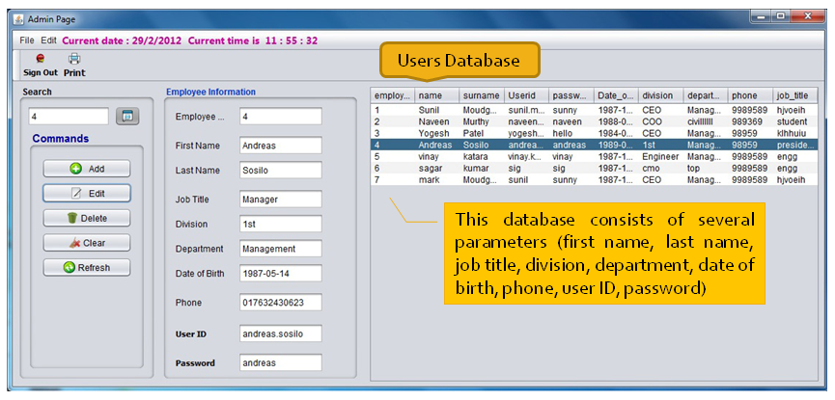
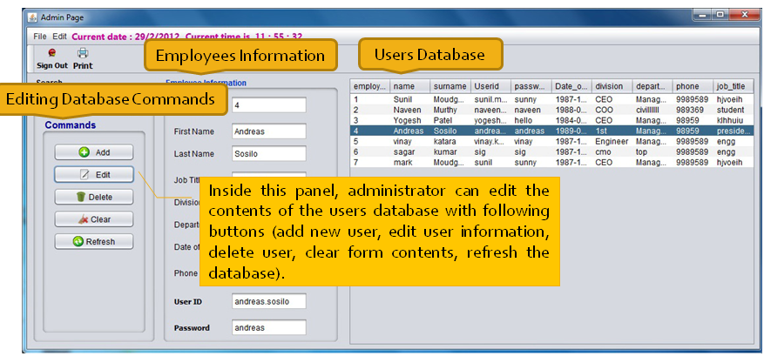
Figure 1

The administration of a business consists of the performance or management of business operations and thus the making or implementing of a major decision. Administration can be defined as the universal process of organizing people and resources efficiently so as to direct activities toward common goals and objectives.
The admin has access to Create Users, Delete Users, Set & Change Passwords for Users, View and edit complete user data.
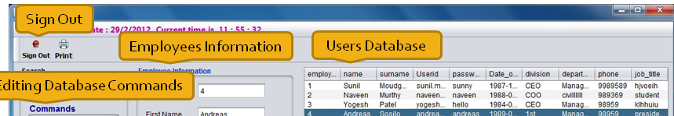
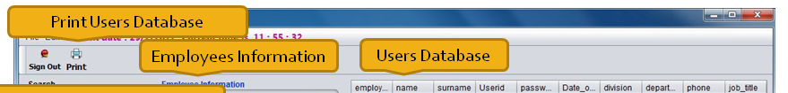
Print button will print the contents of the table .Sign out button is for signing out the admin page.

- Who is User and what data can User access?
The User is an individual who might be a Client or an Employee related to the project.
The User has access to Search Pump Data, Add Pump Data; Monitor the Performance of the Pumps, Generate Reports, and View Performance Charts.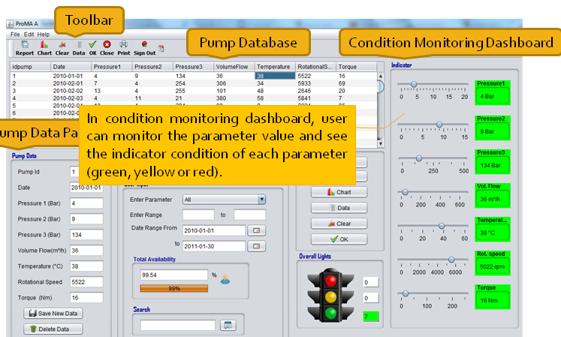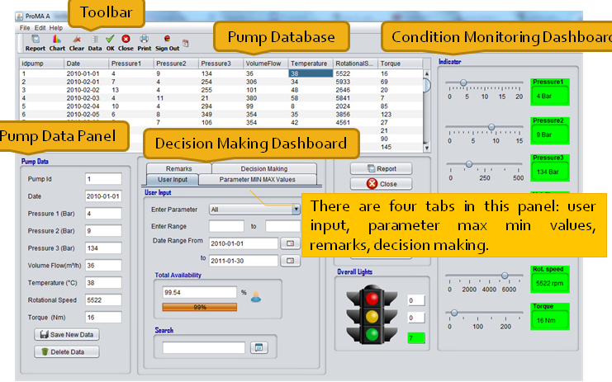

- How does the login page look like & how to login?
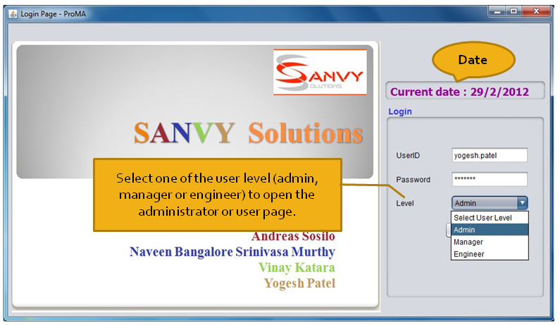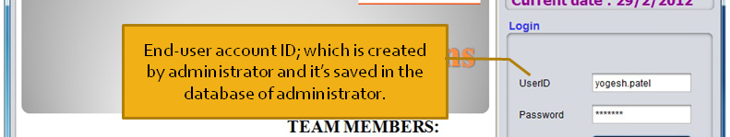
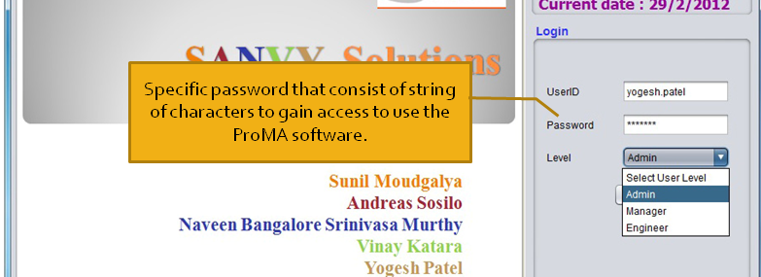
Figure 2
To login into PROMA, one has to enter the username and the password being provided. The software automatically detects if the username has an Admin designation or a User designation and the access rights are provided accordingly (Figure 2).

- How to view the Pump Data?
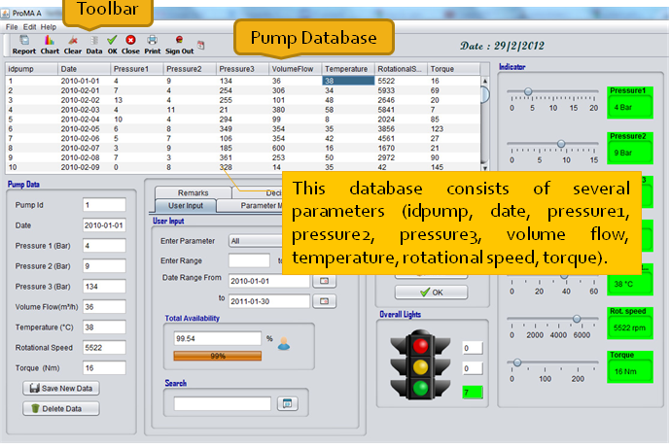
Figure 3
After the successful login, the user can view the Pump Data of 365 days with all the parameters of each day being displayed. The various parameters for each day which can be viewed are Pressure1, Pressure2, Volume Flow Rate, Temperature, Rotational Speed, and Torque. Just click anywhere in the table or press up or down button and you can see the corresponding values in text boxes with the color showing red ,orange and green(which shows value are in limits or not) (Figure 3) .

- What is Availability and how is Availability calculated?

The degree to which a system, subsystem, or equipment is in a specified operable and committable state at the start of a mission, when the mission is called for at an unknown, i.e., a random, time. Simply put, availability is the proportion of time a system is in a functioning condition. This is often described as a mission capable rate. Mathematically, this is expressed as 1 minus unavailability.
The most simple representation for availability is as a ratio of the expected value of the uptime of a system to the aggregate of the expected values of up and down time, or
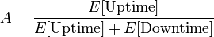
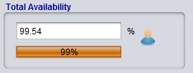
Figure 4
You can directly see the total availability by seeing the User Input tab as shown in (Figure 4).
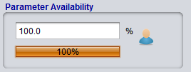
Figure 5
You can also see individual parameter availability by seeing the Remarks tab as shown in (Figure 5).For that you have to choose the desired parameter from the combo box which is shown in (Figure 6)and then pressing ok shown in (Figure 7).
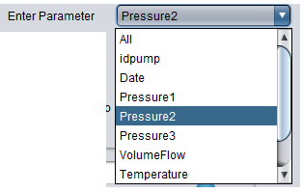
Figure 6
Figure 7

- What does the Indicator display?
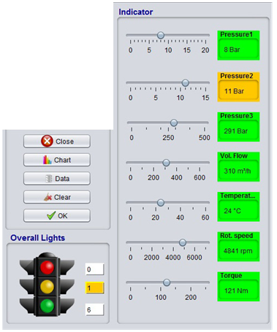
Figure 8
Indicator is similar to a Dashboard which displays the values of each parameter and it also displays whether the value is within the limits or not (Figure 8) .

- How can the Minimum and Maximum Values of each Parameter be known?

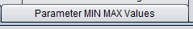
Figure 9
The Minimum and Maximum Values of each Parameter can be known by clicking the ‘Parameter MIN MAX Values’ button in tabbed box. This would be display the minimum and maximum values of each parameter (Figure 9) .

- How can the decision making Dashboard for each parameter be analyzed?
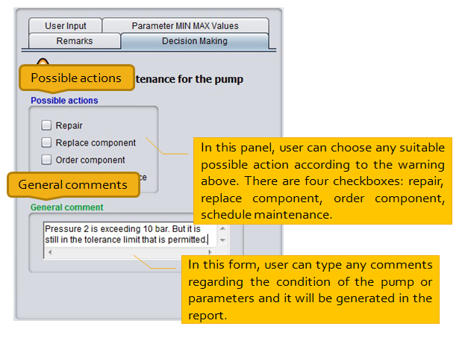
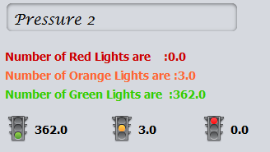
Figure 10

The decision making for each parameter is analyzed similar as a Traffic Signal light. This dashboard can be seen under ‘Remarks’ tab (Figure 10) .
Green – The parameter is within the limiting value. So, the pump is in Ideal Working Condition.
Yellow – The parameter is has a borderline value. The pump is functioning but needs to be checked.
Red - The parameter is above or below the safe limits. So, the pump is working unsafe.

- How can the Pump Data be Saved or Deleted?
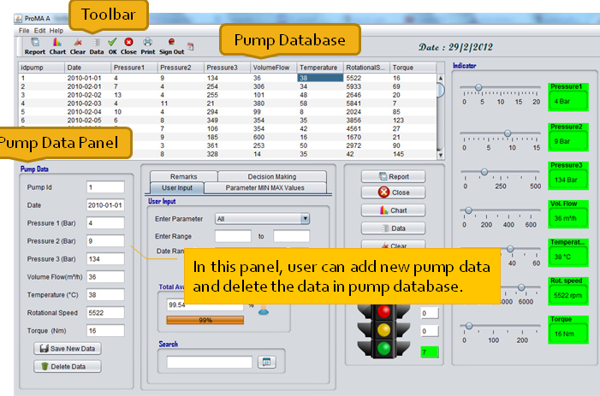
Figure 11
Figure 12
The Pump Data can be easily saved by just inserting the new value. Then the user has to click ‘Save New Data’ (Figure 11) . The data gets updated automatically. In the same way click ‘Delete Data’ button to delete the data (Figure 12) .

- How can the Charts be generated?
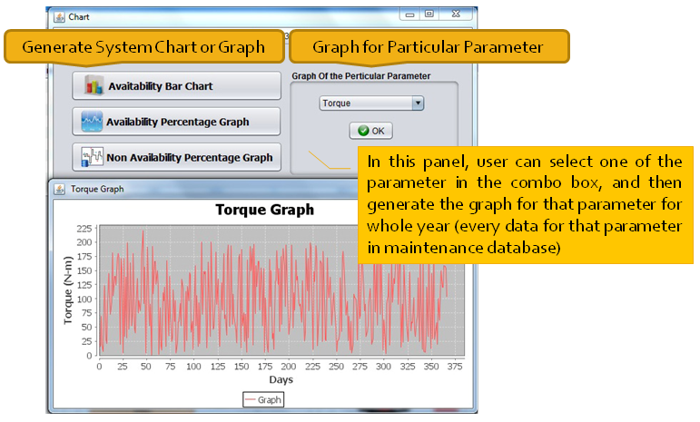
Figure 13
Figure 14
The Charts can be easily generated by clicking the ‘Chart’ button Figure 13) . The Charts can be individually generated for each parameter (Pressure1, Pressure2, Volume Flow Rate, Temperature, Rotational Speed, and Torque) (Figure 14) .

- What is a Report and how can the Report be generated?
Figure 15
The Report can be generated by clicking the ‘Report’ button and this would automatically generate a PDF file which displays the Pump Data for all the 365 days (Figure 15).

